Low-Power Real-Time Colonoscopy Polyp Detection on STM32MP257 NPU
A Multi-Dataset YOLO Training, Quantization, and Edge Deployment Study
Biomedical AI Final Project Report | May 2026

Abstract
Colonoscopy polyp detection is a clinically meaningful computer-aided detection task because the output can directly guide endoscopist attention during a procedure. This project developed a lightweight edge-AI prototype for real-time polyp detection using public gastrointestinal datasets and STM32MP257 NPU deployment. Segmentation annotations from multiple datasets were converted into YOLO bounding boxes, and four YOLO variants were trained under the same multi-dataset protocol: YOLO11n, YOLO26n, YOLOv8n, and YOLOv8s. Cross-dataset evaluation was performed on internal holdout data, CVC-ClinicDB, CVC-ColonDB, and ETIS. YOLOv8s achieved the best external average mAP50-95 of 0.502, while YOLO11n was the strongest nano-scale accuracy candidate with external average mAP50-95 of 0.481. For deployment, YOLOv8n was selected because its full-integer INT8 TFLite model was successfully converted to STM32MP257 NPU format and benchmarked at approximately 35.7 ms per inference, corresponding to 28.0 FPS. The final prototype demonstrates a complete path from public medical datasets to quantized edge inference, while explicitly documenting accuracy, latency, and deployment trade-offs.
Keywords: colonoscopy, polyp detection, YOLO, STM32MP257, NPU, INT8 quantization, edge AI, computer-aided detection

1. Introduction
Colorectal cancer is a major global health burden, and colonoscopy is clinically important because it enables both detection and removal of premalignant lesions. Computer-aided detection (CADe) systems are already clinically relevant in endoscopy, but most commercial systems are high-end and closed. A course-scale project can be clinically convincing if it studies the core workflow: detection of suspected polyps from live-like colonoscopy frames, quantitative external validation, and real-time deployment feasibility on a constrained edge device.
The goal of this project was not to claim clinical readiness. Instead, the goal was to build a rigorous research prototype and measure whether a lightweight YOLO detector can preserve useful cross-dataset accuracy while running in real time on the STM32MP257 NPU after INT8 quantization.
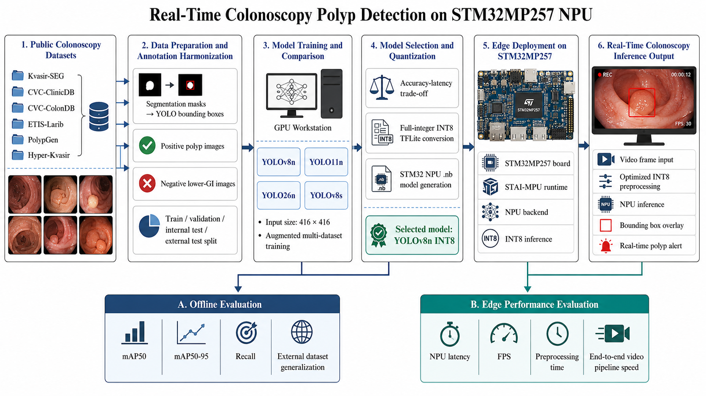
Figure A. Overall system architecture of the proposed colonoscopy polyp detection workflow.
The overall architecture summarizes the complete project path from public endoscopy datasets to model training, quantization, STM32MP257 NPU deployment, and real-time video output. This figure is included early because it connects the clinical task, the machine-learning workflow, and the embedded-AI feasibility study in a single view.

2. Materials and Methods

2.1 Datasets
Multiple public gastrointestinal datasets were used to reduce dependence on a single source distribution. Segmentation masks were converted into YOLO bounding boxes by extracting the bounding rectangle around each positive mask. Negative lower-GI frames were included as empty-label images to improve background rejection.
Dataset | Material | Role
Kvasir-SEG | Image-level colonoscopy polyp dataset with segmentation masks | Converted to YOLO bounding boxes; used in multi-dataset training/validation
PolypGen positive cropped | Positive polyp images with regional annotations | Used as additional positive-domain training and test data
Hyper-Kvasir segmented positives | Lower-GI polyp images with segmentation annotations | Used as additional positive-domain training and test data
Hyper-Kvasir lower-GI negatives | Lower-GI non-polyp frames | Used as negative/background examples to reduce false positives
CVC-ClinicDB | 612 colonoscopy frames with polyp masks | External validation dataset
CVC-ColonDB | 380 colonoscopy frames with polyp masks | External validation dataset
ETIS-LaribPolypDB | 196 colonoscopy frames with polyp masks | External validation dataset
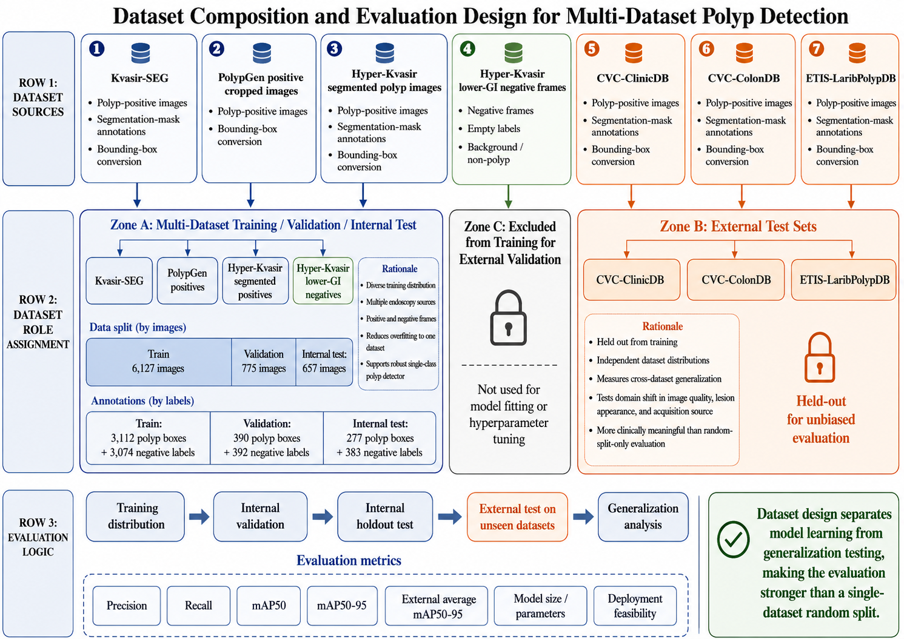
Figure B. Dataset composition and usage across training, validation, internal testing, and external testing.
This figure explains why the datasets were not all used in the same way. Kvasir-SEG, PolypGen, Hyper-Kvasir segmented positives, and Hyper-Kvasir negative lower-GI frames formed the multi-dataset training distribution, while CVC-ClinicDB, CVC-ColonDB, and ETIS were preserved as external tests to assess cross-dataset generalization.

2.2 Annotation Conversion and Data Format
All training data were represented in YOLO detection format. Each image had a corresponding label file containing normalized class, center-x, center-y, width, and height values. Empty label files were retained for negative frames. The final multi-dataset configuration contained 6,127 training images, 775 validation images, and 657 internal test images, with both positive polyp frames and negative lower-GI background frames.
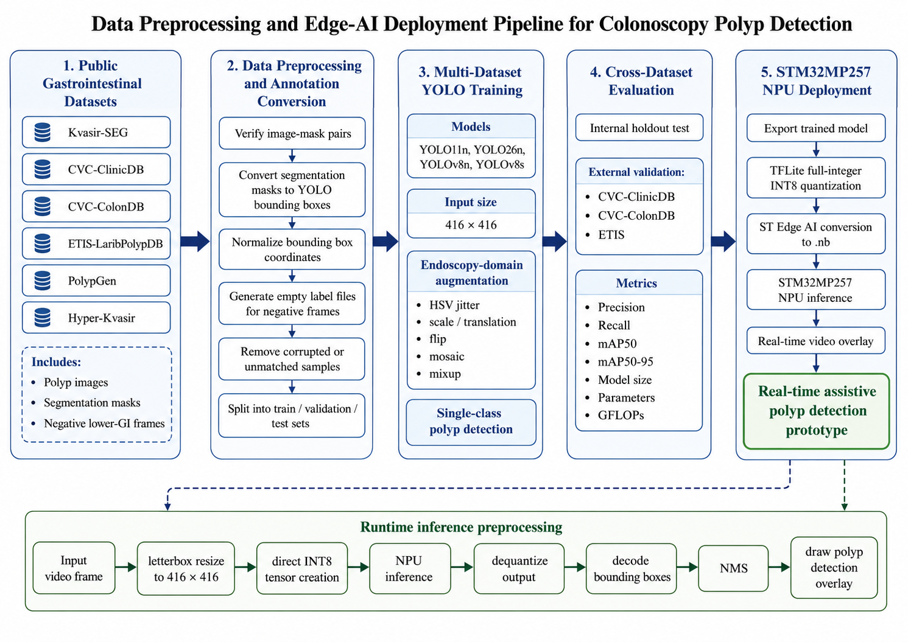
Figure C. Data preprocessing and annotation harmonization pipeline.
The preprocessing pipeline standardizes heterogeneous public datasets into a single YOLO detection format. Segmentation masks are transformed into bounding boxes, image-label pairs are checked, negative frames are represented by empty label files, and the final data are organized into train, validation, internal-test, and external-test subsets.

2.3 Model Training
Item | Setting
Input size | 416 x 416 for the main accuracy comparison
Models | YOLO11n, YOLO26n, YOLOv8n, YOLOv8s
Epochs | 80
Batch size | 32
Optimizer | Ultralytics auto optimizer selection
Seed | 42
Augmentation | HSV jitter, translation, scale jitter, shear, perspective, horizontal/vertical flip, mosaic, mixup
Task | Single-class polyp detection
Evaluation | Internal holdout plus external CVC-ClinicDB, CVC-ColonDB, and ETIS
The four candidate models were trained with identical image size and augmentation settings to make the comparison meaningful. YOLOv8s was included as an accuracy upper-bound model, while YOLO11n, YOLO26n, and YOLOv8n represented nano-scale deployment candidates.
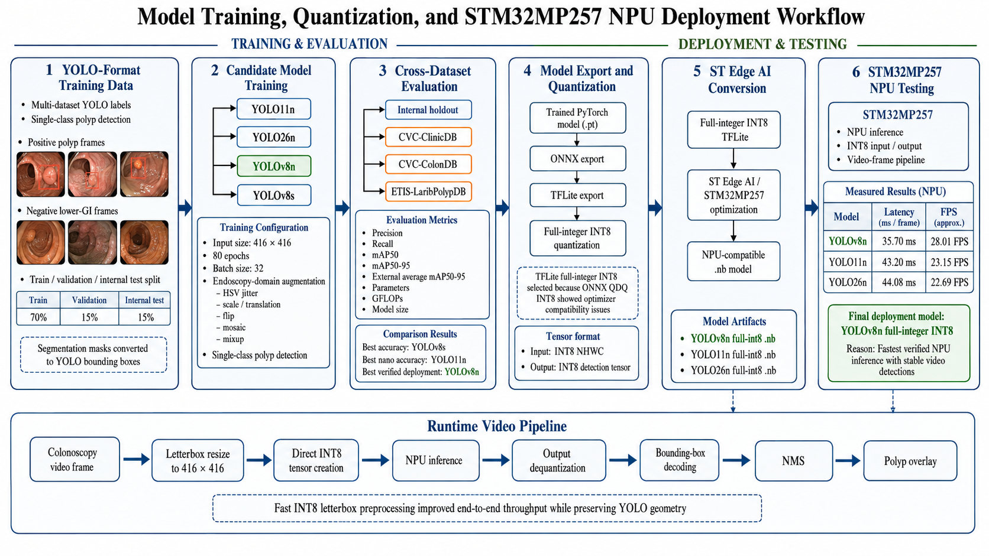
Figure D. Model training, quantization, and deployment conversion workflow.
This workflow shows how the trained YOLO checkpoints were evaluated in PyTorch, exported to deployment formats, converted to full-integer INT8 TFLite when possible, and finally transformed into STM32MP257-compatible .nb files for NPU inference.

2.4 Evaluation Protocol
Accuracy was measured using precision, recall, mAP50, and mAP50-95. The internal holdout result estimates performance within the assembled multi-dataset distribution. External validation on CVC-ClinicDB, CVC-ColonDB, and ETIS was treated as the key generalization test because it evaluates domain shift across independent datasets.

2.5 Quantization and STM32MP257 Deployment
Deployment experiments used TFLite full-integer INT8 quantization when possible. The TFLite route was more reliable than ONNX QDQ quantization for STM32MP257 NPU optimization. Models were converted into .nb files using ST Edge AI tooling and executed through the STAI MPU runtime on the STM32MP257 board.
Artifact | Tensor format | Outcome
YOLOv8n 416 full-integer TFLite | Input int8 [1,416,416,3]; output int8 [1,5,3549] | Converted successfully to .nb; NPU validated
YOLOv8n 384 full-integer TFLite | Input int8 [1,384,384,3]; output int8 [1,5,3024] | Prepared for future speed/accuracy trade-off testing
YOLOv8n 320 full-integer TFLite | Input int8 [1,320,320,3]; output int8 [1,5,2100] | Prepared for aggressive speed testing
YOLO11n full-integer TFLite/.nb | Input int8 [1,416,416,3]; output int8 [1,5,3549] | Converted to .nb and validated on STM32MP257 NPU
YOLO26n full-integer TFLite | Input int8 [1,416,416,3]; output int8 [1,300,6] | Converted to .nb and validated, but inferior to YOLOv8n in deployment tests
ONNX QDQ INT8 variants | Several QDQ and conv-only variants tested | ST optimizer compatibility was unreliable; TFLite route was preferred

3. Results

3.1 Cross-Dataset Accuracy
YOLOv8s achieved the best external average mAP50-95, but with a much larger model. Among compact models, YOLO11n achieved the highest external average mAP50-95, while YOLOv8n remained the most reliable deployment candidate after NPU conversion.
Model | Params (M) | GFLOPs | PT MB | Internal mAP50-95 | External Avg mAP50-95 | External Avg Recall | CVC | ColonDB | ETIS
YOLOv8s | 11.14 | 12.10 | 22.51 | 0.774 | 0.502 | 0.762 | 0.559 | 0.455 | 0.493
YOLO11n | 2.59 | 2.72 | 5.47 | 0.748 | 0.481 | 0.703 | 0.548 | 0.425 | 0.471
YOLO26n | 2.50 | 2.44 | 5.39 | 0.768 | 0.478 | 0.690 | 0.579 | 0.426 | 0.428
YOLOv8n | 3.01 | 3.46 | 6.24 | 0.756 | 0.465 | 0.720 | 0.536 | 0.408 | 0.452

3.2 Per-Dataset Model Performance
Model | Dataset | Precision | Recall | mAP50 | mAP50-95
YOLO11n | internal_holdout | 0.946 | 0.893 | 0.952 | 0.748
YOLO11n | cvc_clinicdb | 0.892 | 0.768 | 0.863 | 0.548
YOLO11n | cvc_colondb | 0.825 | 0.676 | 0.792 | 0.425
YOLO11n | etis | 0.873 | 0.663 | 0.757 | 0.471
YOLO26n | internal_holdout | 0.924 | 0.918 | 0.953 | 0.768
YOLO26n | cvc_clinicdb | 0.846 | 0.812 | 0.866 | 0.579
YOLO26n | cvc_colondb | 0.799 | 0.661 | 0.764 | 0.426
YOLO26n | etis | 0.708 | 0.597 | 0.685 | 0.428
YOLOv8n | internal_holdout | 0.942 | 0.928 | 0.959 | 0.756
YOLOv8n | cvc_clinicdb | 0.842 | 0.815 | 0.871 | 0.536
YOLOv8n | cvc_colondb | 0.824 | 0.650 | 0.774 | 0.408
YOLOv8n | etis | 0.710 | 0.694 | 0.751 | 0.452
YOLOv8s | internal_holdout | 0.952 | 0.940 | 0.966 | 0.774
YOLOv8s | cvc_clinicdb | 0.849 | 0.819 | 0.858 | 0.559
YOLOv8s | cvc_colondb | 0.792 | 0.731 | 0.808 | 0.455
YOLOv8s | etis | 0.833 | 0.735 | 0.803 | 0.493

3.3 Figures
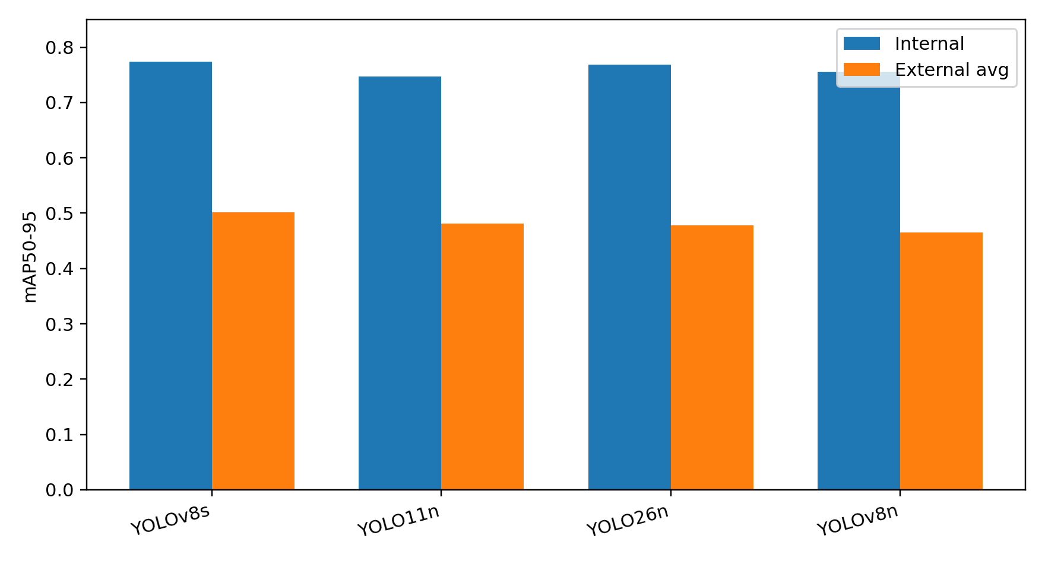
Figure 1. Internal holdout and external-average mAP50-95 for the four trained YOLO models.
This figure compares in-distribution performance with external-dataset generalization. The gap between internal and external mAP50-95 indicates domain shift across public endoscopy datasets, which is why external testing is more persuasive than reporting a single internal split alone.
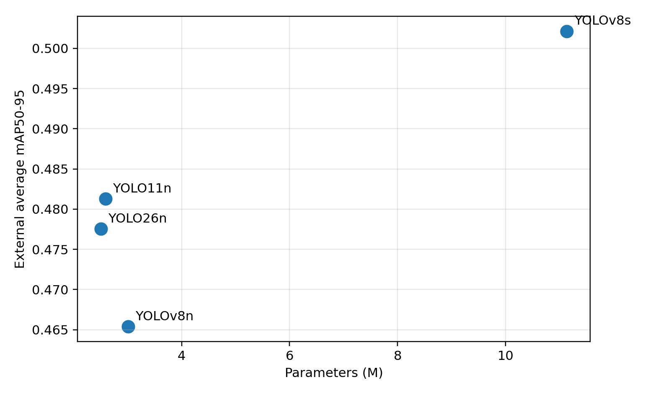
Figure 2. Accuracy-deployment trade-off: parameter count versus external-average mAP50-95.
This figure is the first part of the model-selection argument. YOLOv8s is the accuracy leader but is clearly separated by model size. The nano-scale models occupy a smaller-parameter region, so the final decision must also consider measured NPU latency and video stability rather than parameter count or mAP alone.
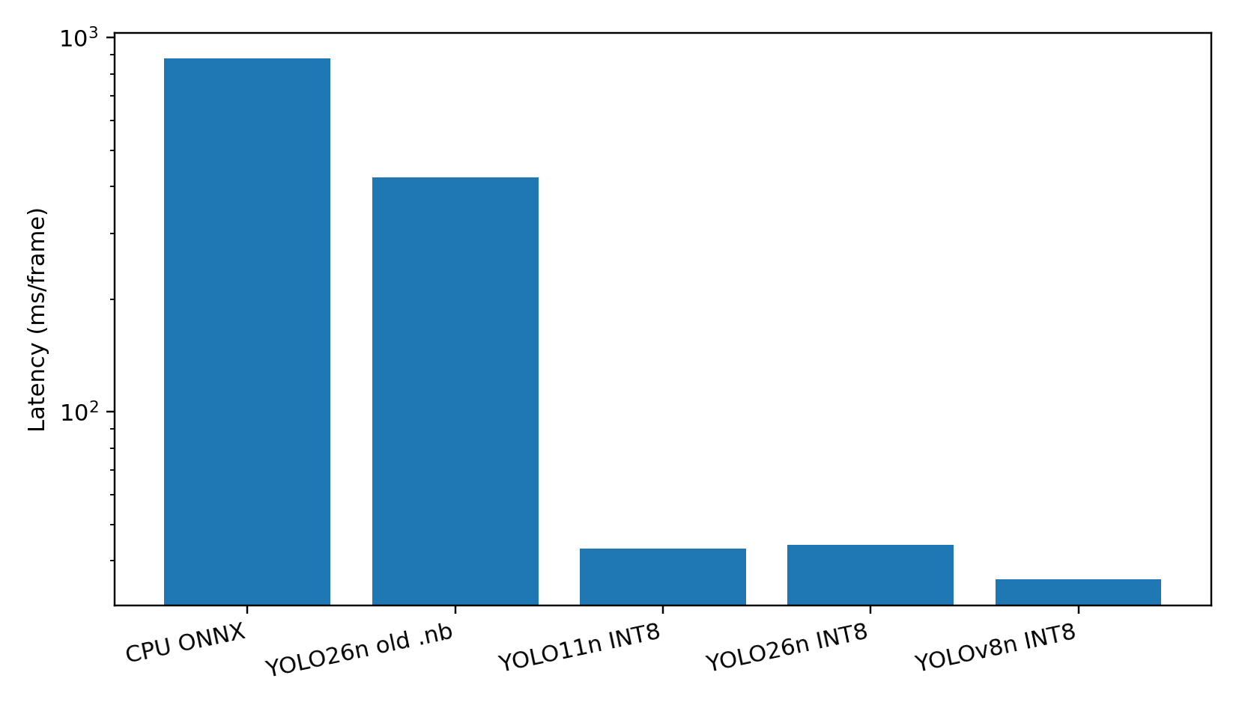
Figure 3. STM32MP257 inference latency comparison. Log scale highlights the improvement from CPU ONNX to INT8 NPU execution.
The latency comparison demonstrates the practical value of full-integer NPU deployment. YOLOv8n INT8 achieved the lowest measured NPU latency among the validated .nb models, which is the main deployment reason it was selected as the final demo model.
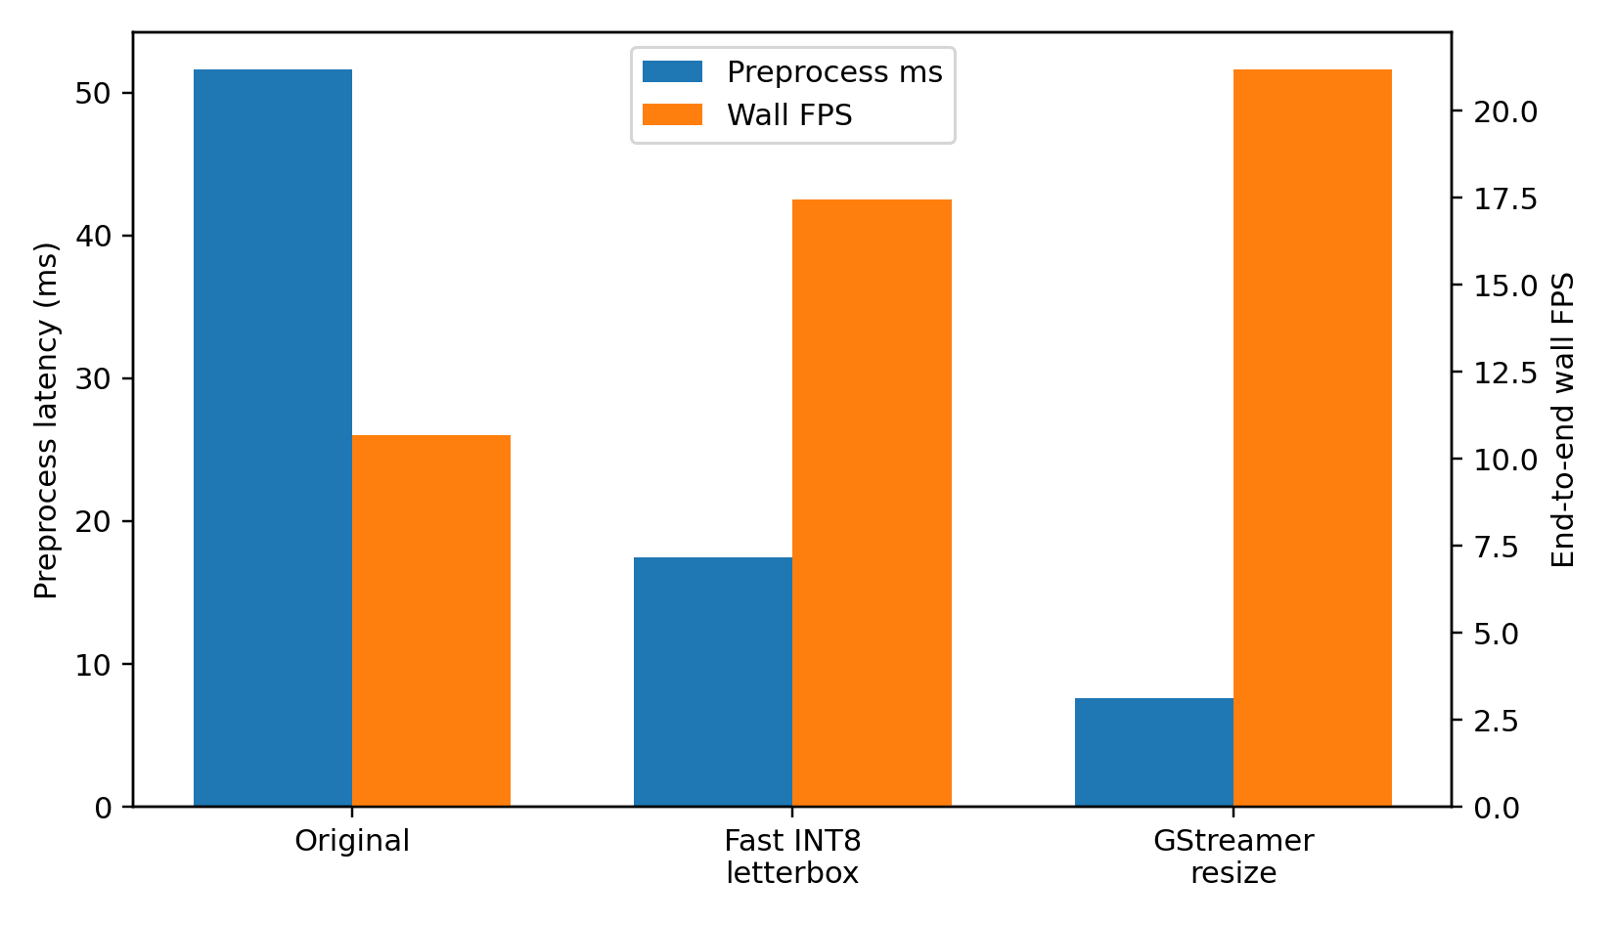
Figure 4. Preprocessing optimization reduced Python overhead and improved end-to-end video throughput.
This figure shows that the embedded pipeline bottleneck was not limited to neural network inference. Direct INT8 letterbox preprocessing reduced CPU-side overhead while preserving YOLO geometry, making it the preferred real-time video route.

3.4 Model Selection and Accuracy-Latency Trade-off
The final model was selected by combining two types of evidence rather than by using mAP alone. First, the parameter-versus-external-mAP figure shows the accuracy and model-complexity relationship. Second, the STM32MP257 deployment table measures the actual NPU latency and video-detection stability of the converted INT8 .nb models.
YOLOv8s achieved the strongest accuracy result, with external average mAP50-95 of 0.502 and internal mAP50-95 of 0.774, but it used 11.14M parameters and therefore served mainly as an accuracy upper bound. YOLO11n was the strongest nano-scale accuracy model, with external average mAP50-95 of 0.481 and 2.59M parameters, but its STM32MP257 NPU latency was 43.20 ms. YOLO26n was similarly compact but showed weaker deployment stability in the sample video. YOLOv8n had slightly lower external average mAP50-95 of 0.465, but it provided the fastest verified NPU inference at 35.70 ms and the most defensible complete deployment path.
Model | Accuracy and size evidence | NPU deployment evidence | Decision
YOLOv8s | 11.14M parameters; internal mAP50-95 0.774; external average mAP50-95 0.502. | Not selected for final embedded demo because it is the largest model and was used as the accuracy upper bound. | Best accuracy, but less suitable for the low-power real-time deployment target.
YOLO11n INT8 | 2.59M parameters; internal mAP50-95 0.748; external average mAP50-95 0.481. | Validated on STM32MP257 NPU: 43.20 ms, 23.15 FPS. | Best nano accuracy, but slower than YOLOv8n on the target NPU.
YOLO26n INT8 | 2.50M parameters; internal mAP50-95 0.768; external average mAP50-95 0.478. | Validated on STM32MP257 NPU: 44.08 ms, 22.69 FPS; lower video detection stability. | Compact, but not the strongest accuracy or deployment candidate.
YOLOv8n INT8 | 3.01M parameters; internal mAP50-95 0.756; external average mAP50-95 0.465. | Validated on STM32MP257 NPU: 35.70 ms, 28.01 FPS; stable sample-video detections. | Selected final model because it provides the best verified NPU deployment trade-off.
Therefore, the parameter/mAP plot supports the accuracy-complexity part of the decision, while the NPU comparison table provides the deployment feasibility evidence. Together, they justify selecting YOLOv8n INT8 as the final model for the STM32MP257 demonstration instead of selecting the highest-mAP model alone.

3.5 Embedded Inference and NPU Deployment
Experiment | Runtime format | Latency | FPS | Interpretation
YOLOv8n ONNX CPU on STM32MP257 | FP32 ONNX Runtime CPU | 879.63 ms/frame | 1.14 FPS | Baseline fallback; not real-time
YOLO26n previous .nb | NPU, float16 I/O | 422.70 ms | 2.37 FPS | Not true INT8 behavior; rejected
YOLO11n full-integer .nb | NPU, int8 I/O | 43.20 ms | 23.15 FPS | NPU validated; detection stability close to YOLOv8n but slower
YOLO26n full-integer .nb | NPU, int8 I/O | 44.08 ms | 22.69 FPS | Runs on NPU but lower video-detection stability
YOLOv8n full-integer .nb | NPU, int8 I/O | 35.70 ms | 28.01 FPS | Selected embedded demo model

3.6 End-to-End Video Pipeline Optimization
NPU inference alone was not the only bottleneck. Python preprocessing initially dominated the end-to-end video pipeline. A direct INT8 letterbox preprocessing path reduced preprocessing cost while preserving the same detection behavior. A GStreamer resize pipeline was faster but changed image geometry and reduced detections on the sample video, so it was not selected as the final demonstration pipeline.
Pipeline | Description | Preprocess ms | NPU ms | Decode/NMS ms | Wall FPS | Detected frames
Original Python pipeline | Standard resize, RGB conversion, float normalization, quantization, NMS | 51.64 | 36.36 | 1.47 | 10.68 | 87/200
Fast INT8 letterbox pipeline | Direct INT8 tensor creation while preserving YOLO letterbox geometry | 17.47 | 36.59 | 1.64 | 17.44 | 87/200
GStreamer direct resize | GStreamer decode/resize before Python; direct 416x416 stretch | 7.60 | 37.48 | 1.20 | 21.19 | 45/200
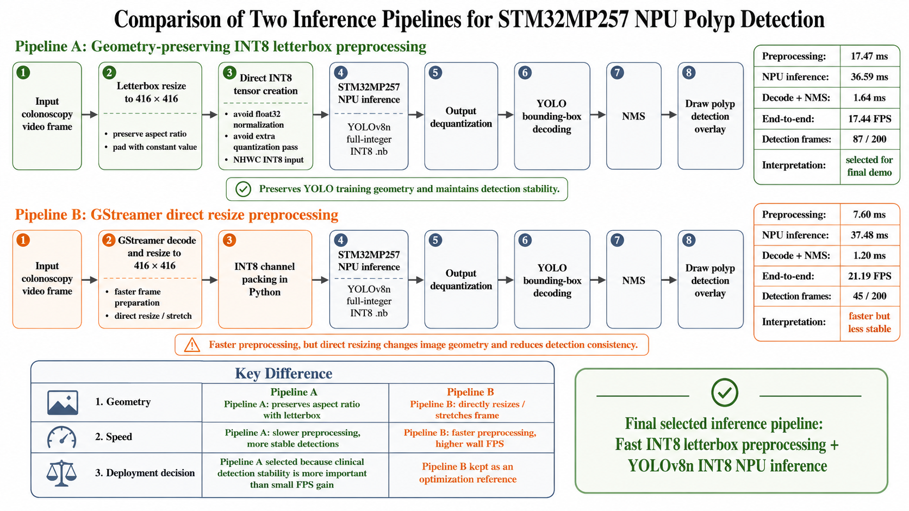
Figure E. Two STM32MP257 inference pipelines evaluated for end-to-end video deployment.
The pipeline diagram clarifies that NPU inference time is only one part of the embedded system. The final selected route keeps YOLO letterbox geometry and generates the INT8 tensor directly, while the faster GStreamer direct-resize route sacrifices geometric consistency and reduced detections in the sample video.

4. Discussion
The results support the clinical and engineering feasibility of the project. The clinical relevance comes from the direct link between model output and procedural attention: a highlighted suspected polyp can prompt closer inspection during colonoscopy. The engineering contribution is the measured path from public datasets to NPU-executed INT8 inference on STM32MP257.
The model comparison shows a clear accuracy-deployment trade-off. YOLOv8s is the best accuracy model, but its 11.14M parameters and higher compute make it less attractive for low-power real-time deployment. YOLO11n is the strongest nano-scale accuracy candidate and was successfully converted to a full-integer INT8 .nb model; however, its measured STM32MP257 NPU latency was 43.20 ms, slower than YOLOv8n. YOLO26n is compact, but its full-integer INT8 NPU version was also slower and produced lower detection stability in the sample video. Therefore, YOLOv8n is the most defensible final demonstration model.
The preprocessing experiments are also important. They show that achieving real-time performance is not only a neural-network problem. On an embedded system, image decode, resize, channel conversion, quantization, NMS, and overlay rendering must also be measured. Optimizing preprocessing from a float-based Python route to a direct INT8 letterbox route improved the usable video pipeline while preserving model geometry.

5. Limitations
- This is a research prototype and not diagnostic or regulatory-grade software.
- The datasets are public research datasets and do not replace prospective patient-level clinical validation.
- The video demonstration uses dataset-derived video rather than direct integration with a clinical colonoscope.
- INT8 quantization and NPU conversion can change score calibration and may require threshold tuning.
- YOLOv8n 384 and 320 full-integer INT8 TFLite models were prepared for future speed tests, but their .nb accuracy and NPU latency were not finalized in this report.

6. Conclusion
This project demonstrates a clinically motivated and technically complete edge-AI prototype for colonoscopy polyp detection. Multi-dataset training and external validation provide a stronger evaluation than a single-dataset experiment. YOLOv8s achieves the best external accuracy, but YOLOv8n is selected as the final deployment model because it has the strongest verified STM32MP257 NPU path: full-integer INT8 input/output, approximately 35.7 ms NPU inference, and a functional video inference pipeline. The final result is suitable for a biomedical AI final project because it connects clinical motivation, model comparison, quantization, embedded deployment, and measured accuracy-latency trade-offs.

7. Reproducibility Package
Item | Path
Multi-dataset YAML | data/processed/polyp-multidata/polyp-multidata-local.yaml
Training config | configs/training_multidata_augmented.yaml
Evaluation CSV | runs/multidata_compare_eval_4models/multidata_eval.csv
Model summary CSV | runs/multidata_compare_eval_4models/model_summary.csv
YOLOv8n NPU model | models/int8/yolov8n_polyp_416_full_integer_int8_1.nb
YOLO11n NPU model | models/int8/yolo11n_polyp_416_full_integer_int8_1.nb
YOLO26n NPU model | models/int8/yolo26n_polyp_416_full_integer_int8_1.nb
STM32 NPU comparison CSV | runs/stm32_inference/stm32_npu_model_comparison.csv
STM32 video inference script | deployment/stai_yolo_video.py

References
- World Health Organization. Colorectal cancer fact sheet. https://www.who.int/news-room/fact-sheets/detail/colorectal-cancer
- CDC. Screening for Colorectal Cancer. https://www.cdc.gov/colorectal-cancer/screening/
- Kvasir-SEG dataset. Simula. https://datasets.simula.no/kvasir-seg/
- CVC-ClinicDB dataset. https://polyp.grand-challenge.org/CVCClinicDB/
- STMicroelectronics. STM32MP257 product family and NPU documentation. https://www.st.com/
- Ultralytics YOLO documentation. https://docs.ultralytics.com/

